**Robert Bryant**

**ITSC 3155**

**Design Sprint Day 1**

**As a group:**

1. Identify the personas/imagined users for the products
   1. Doctors.
   2. Patients with cancer.
   3. Family members of those with cancer.
   4. People interested in supporting those with cancer.
   5. Charities related to cancer.
   6. People interested in cancer research.
2. Identify other stakeholders of the projects (People other than direct users who you could require data or input from or who may indirectly benefit from the product).
   1. Those with cancer would also qualify here.
   2. Charities.
   3. People interested in cancer research.
   4. Doctors interested in dispersal of cancer cases.
3. Each member of the group should act as an expert for the "Ask the expert section"
   1. “How can we display locations to find cancer treatment?”
   2. “How can we include pertinent information to different types of cancer?”
   3. “How can we find charities that are involved with cancer research and connect them?”
   4. “How can we spread awareness about cancer through this site?”

**Individual:**

User Map

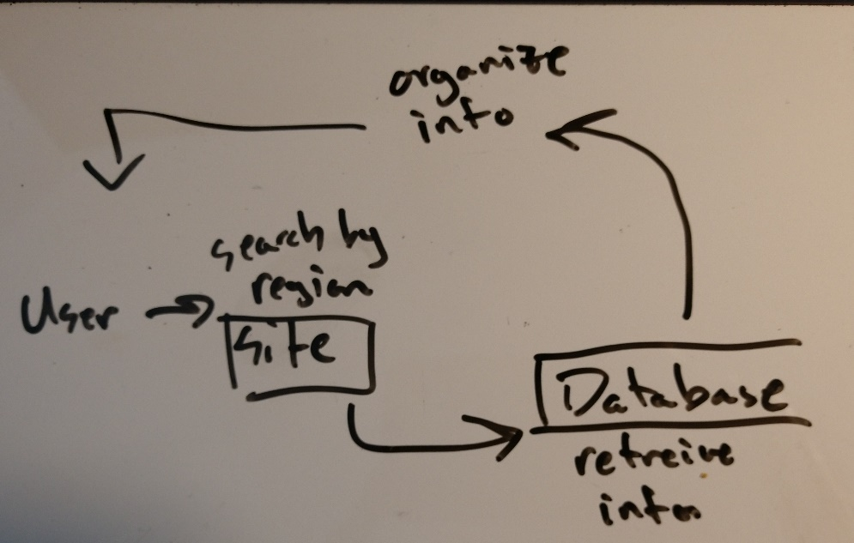

User Stories

As a medical researcher I want to know where certain types of cancer occur most so I can gather more information for my research.

As a loved one of a cancer patient I want to gather more information about the cancer so I know what to expect.

Scenarios

Stacey is a medical researcher who is gathering information on cervical cancer. She wants to move and live in an area where that type of cancer is more prevalent. This way she can gather more information to better her research.

Philip’s brother was just diagnosed with brain cancer. As a concerned loved one he wants to gather as much information about the disease as he can. He would like to know what areas have a higher concentration so he can potentially locate good support as well as possible medical treatment.

Sidney is a high school student that has to write an essay and chose to do it on lung cancer. As part of the assignment she’ll need an easy and reliable way to find data on mortality rates, recovery rates, and what areas of the world it can be found more.

Feature List

The website can include features that:

* Organize information by region
* Organize information by cancer type
* Filter information according to different statistics including:
  + Mortality rate
  + Prognosis
  + Location of occurrence